ASSIGNMENT 2:

TASK 1:

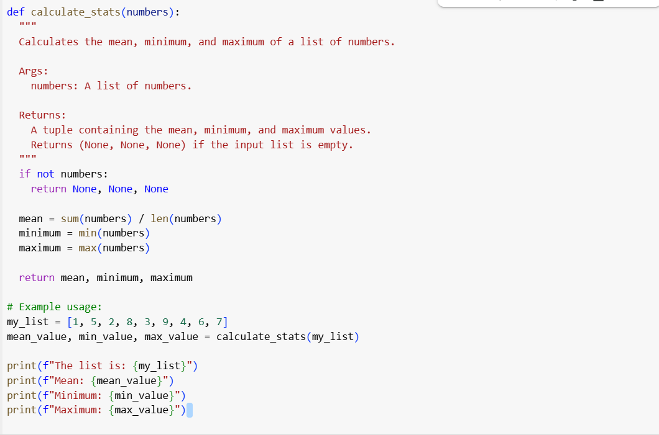

Explanation:

TASK 2:



TASK 3:

TASK 4:

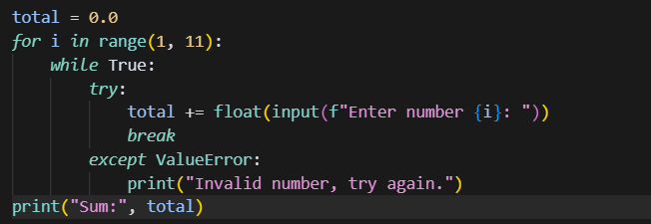

TASK 5:



